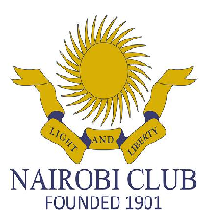

INTERNAL MEMO

Exciting career opportunities

We are currently looking for a talented individual to fill the following positions in the club:

MASSEUS

Summary details of the position:
The masseur is required to perform massage services to members of the Club both Male and female at the health Club. This will be to the terms and conditions of service as set at the discretion of the Club.

Responsibilities:
The candidate’s Responsibilities and essential job functions include attending to members in the Health and Fitness Department but the functions and duties may be altered at the discretion of Management.

OCCASIONAL DUTIES
The candidate shall be required
- Assist Food & Beverage management team with stock-take as requested.
- Assist in transporting of food, beverage and other items to and from the kitchen.
- Assist kitchen team in replenishing food items, crockery, cutlery, etc. on special functions/busy periods.
- Attend Department meetings as requested.

Qualifications:
- Must have attained O’level education (form 4) with minimum grade of D Plain and above
- Health Certificate
- Minimum 2 years experience
- Highly responsible & reliable
- Ability to work well under pressure in a fast paced environment
- Ability to work cohesively as part of a team
- Ability to focus attention on guest needs, remaining calm and courteous at all times

Special Requirements:
- As this is a long hour operation you must be able to work overtime, holidays, and weekends if and when required.
- On call at all times.

Applications including current CVs stating the post as indicated above should be sent by email to:
ceo@nairobiclub.com, not later than 18th October, 2019 by 5:00pm.Applications and CVs must be in MS Word, with no attachments.

